**JDBC Assignment**

You are required to create a database for a Cloud/Game topic of your choice and connect to this database from a Java GUI using JDBC. You should base your work on the **template** given. Your assignment should:

1. Create a relational database, you will need to submit the setup script for your database.
2. Implement Create, Read, Update and Delete (CRUD) operations
3. Using the functionality of the “Export Data” panel on the template GUI provided as a guideline, implement exports that query relevant data and export it in CSV format. Use appropriate Stored Programs. .
4. Visualization – create charts to present results for relevant queries.
5. Write a word document (max 5 pages) with the following:
   1. The key concept of your project – what can it be used for? What information does it give the user?
   2. A snapshot of your java GUI
   3. The highlights of your project e.g. a stored program you created
   4. Conclusion - what are the main benefits to an end user of the JDBC application you have created? What did you learn?

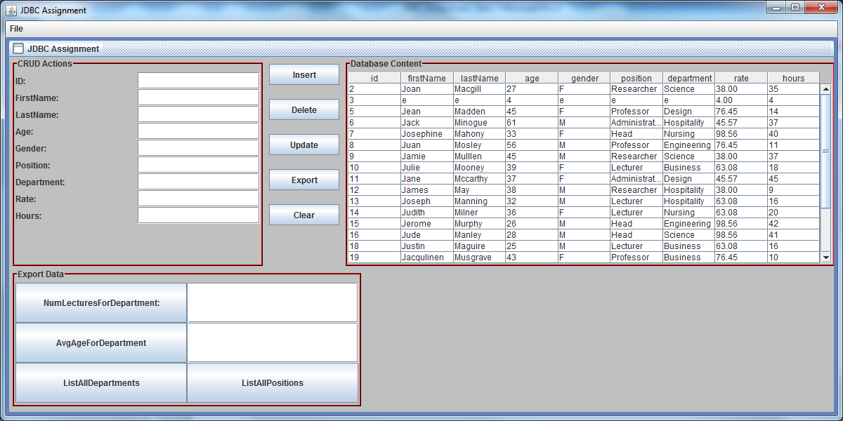

**Submission Instructions**

You must submit a zip file via Moodle containing your

1. Completed A1 plagiarism form
2. Word document, as described in Task 5 above.
3. java project files
4. database setup script
5. data visualization e.g. Charts/ Excel files showing your exported data and any charts you have created from that data
6. An mp4 video file, with voice, of you presenting your project. At the start of this video, you should show the tables in the database. Then you must show all buttons on your project working (or attempted). Show all output to files. You must show all extra features also, e.g. stored procedure etc. You can use e.g. screencastOmatic to create your video. <https://screencast-o-matic.com/screen-recorder>. This video should be a max of 3 minutes.